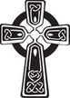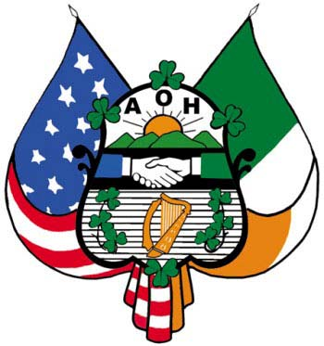

**DIVISON USE ONLY**

**Sponsor’s Certification**

I hereby certify on my honor as a member of the Ancient Order of Hibernians, that I am acquainted with the applicant. I know him to be a practicing Roman Catholic, and worthy in every way to become a member of this Order.

___________________________

Sponsor’s Signature

**Report on Application**

**Division President’s Certificate**

This applicant was referred to the committee and we would respectively report that we have investigated the qualifications of said applicant for membership and recommend him.

__________________________

Committee Chairman Signature

**Division President's Certificate**

I hereby certify that this application has been read by me at a regular meeting and applicant has been elected by the membership of this division on the: _________ day of ____________ 20______

**Financial Secretary Certificate**

I hereby certify that the initiation fee of $____ has been paid on this ____ day of _______ 20___ Financial Secretary _____________________

Membership Number: ___________________

**We want to know your interests!**

**Please Check all that Apply**

* Veteran Branch __________
* Freedom for All Ireland
* Missions/Charities
* Division Golf Tournament
* Division Golf League
* Division Picnic
* Division Darts
* Roisin Dubh Irish Pipe Band
* Jr. AoH/LAoH
* Irish History
* Fundraising
* Other: ____________

**Membership**

**Application**

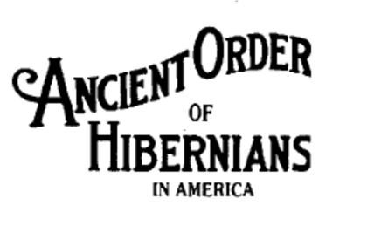

SUFFOLK COUNTY

NEW YORK

DIVISION 7

**Bob Knockenhauer**

**631-277-2872**

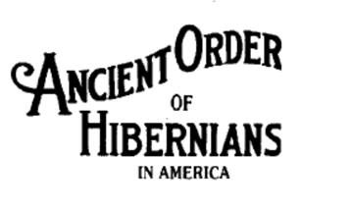

Cell Phone: ___________________________

**What** **is** **the**

**Ancient** **Order** **of** **Hibernians**

**In** **America?**

Active across the United States, The Order seeks to

aid the newly arrived Irish, both socially and politi-

cally. The many Divisions and club facilities located

throughout the U.S. traditionally have been among

the first to welcome new Irish Americans. Here, the

Irish culture; art, dance, music, and sports are fos-

tered and preserved. The newcomers can meet

some of "their own" and are introduced to the social

atmosphere of the Irish-American community. The

AOH has been at the political forefront for issues

concerning the Irish, such as Immigration Reform;

Economic Incentives both here and in Ireland; the

human rights issues addressed in the MacBride

Legislation; Right-To-Life; and a peaceful and just

solution to the issues that divide Ireland.

**APPLICATION** **FOR** **MEMBERSHIP**

I hereby apply for admission into the Ancient

Order of Hibernians in America, Inc. and

continuance in said Order shall depend upon

the truthfulness of my answers to the Ques-

tions which are attached, and my admission

into the Order. You must be Irish by birth or

descent and a practicing Roman Catholic to

be a member.

Full Legal Name __________________________

Address ________________________________

City__________________State____Zip _______

The Ancient Order of Hibernians is a Catholic, Irish

American Fraternal Organization founded in New

York City on May 4, 1836. The Order can trace its

roots back to a parent organization, of the same

name, which has existed in Ireland for over 300

years. However, while the organizations share a

common thread, the North American A.O.H. is a

separate and much larger organization.

The Order has also provided a continuing bridge

with Ireland for those who are generations removed

from our country. The AOH sponsors many of the

programs associated with promoting our Irish Her-

itage such as the IRISH WAY PROGRAM.

Birth Date ______________________________

Occupation ______________________________

E-mail: (H) ______________________________

E-mail: (W) _____________________________

You may further seek admittance to the FINEST

Irish Catholic Organization in the World--all we

would ask is for you to live our motto of: Mother's Maiden Name _____________________

Phone: (H) ______________________________

hundreds to protect the lives of priests who risked

immediate death to keep the Catholic Faith alive in

occupied Ireland after the reign of England's King

Henry VIII. When England implemented its dread-

ed Penal Laws in Ireland, various secret social soci-

means available. Similarly, the Ancient Order of Hi-

at New York's St. James Church, to protect the cler-

gy, and church property from the "Know Nothings"

of Irish Immigrants fleeing famine issues in Ireland

social societies in the USA the largest of which was,

and continues to be, the Ancient Order of Hiberni-

ans.

The Order evolved from a need in the early sixteen Are You Roman Catholic? _____Yes _____No

eties were formed across the country. These groups Do you belong to any society(ies) that the Catholic

worked to aid and comfort the people by whatever Church is opposed? _____Yes _____No

bernians in America was founded on May 4th, 1836 Parish Name: ____________________________

and their followers. At the same time the vast influx _____Yes _____No

in the late 1840's, prompted a growth of various Sponsor: _______________________________

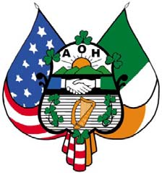

**"Friendship,** **Unity,** **and** **Christian** **Charity"**

**Dia's** **Muire** **dhuit!**

Are You Irish? _____Yes _____No

Have you complied with your religious duties within the

past twelve (12) months? _____Yes _____No

Have you ever been a member of the AOH?

I do solemnly pledge my sacred word and honor that the

answers I have given to the above questions are true.

Applicant's Signature_______________________